DEGREE OF ACCURACY
Pearson Edexcel - Tuesday 11 June 2019 - Paper 3 (Calculator) Higher Tier
1.
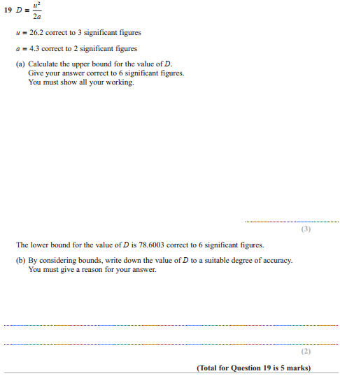

Pearson Edexcel - Monday 12 November 2018 - Paper 3 (Calculator) Higher Tier
2.

Pearson Edexcel - Thursday 7 June 2018 - Paper 2 (Calculator) Higher Tier
3.
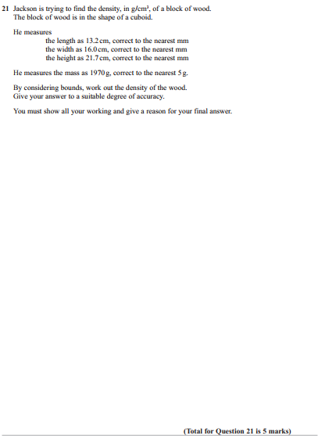

Pearson Edexcel - Tuesday 13 June 2017 - Paper 3 (Calculator) Higher Tier
4.
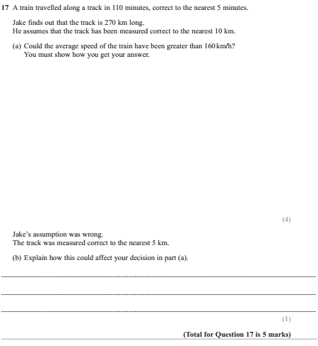
Pearson Edexcel - Specimen Papers Set 1 - Paper 3 (Calculator) Higher Tier
5.
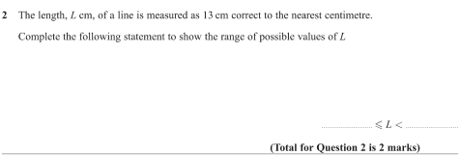
Pearson Edexcel - Sample Paper 2 - (Calculator) Higher Tier
6.
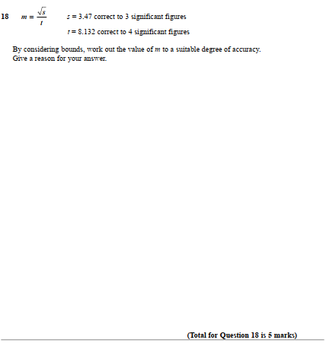

Pearson Edexcel - Sample Paper 2 - (Calculator) Higher Tier
7.
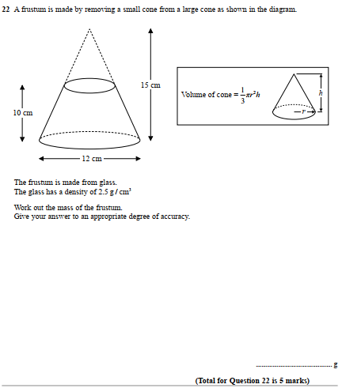

Pearson Edexcel - Monday 4 March 2013 - Paper 2 (Calculator) Higher Tier
8.
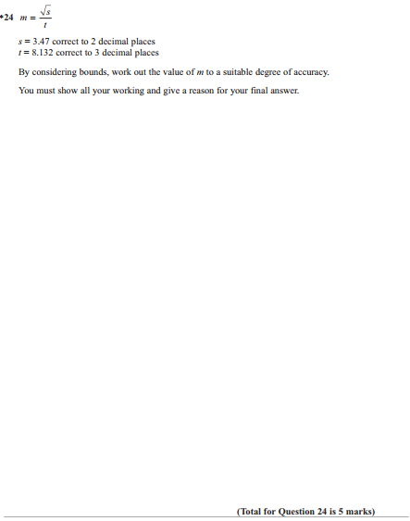

Pearson Edexcel - Monday 5 March 2012 - Paper 4 (Calculator) Higher Tier
9.
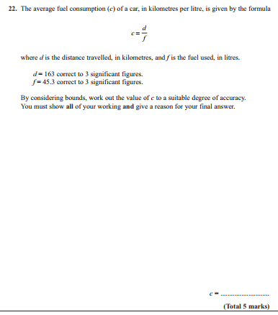

Pearson Edexcel - Tuesday 10 November 2009 - Paper 4 (Calculator) Higher Tier
10.
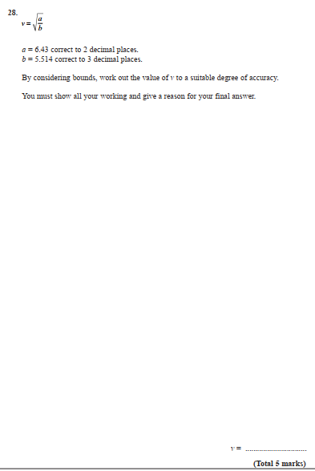
11.

